Consumption Map & Interaction Cost Analysis
Clinical Microbiology Setup & Resulting
Current State vs. Proposed Workflow

PRODUCT | Clinisys Laboratory Solution (CLS)
PREPARED BY | Rossana Babakhani, UX Researcher
ANALYSIS METHOD | Comparative Workflow Analysis

CONTENTS
Table of Contents
Overview 1
Study Snapshot 1
Background & System Constraints 1
Objectives 1
Methodology 1
Workflow Comparison 1
Summary 1
Key Findings 1
Workflow Value Assessment 1
Prioritized Recommendations 1
Research Impact 1
Benefits Identified 1
Tradeoffs 1
Overall Assessment 1
Conclusion 1

01 Overview
Following the usability evaluation of the Clinical Microbiology Setup & Resulting prototype, stakeholders expressed concerns that the proposed task-based workflow appeared to require more user interactions than the existing application.
To objectively evaluate this perception, a Consumption Map and Interaction Cost Analysis was conducted comparing representative workflows in the current system with the proposed design. The analysis quantified interaction costs across both workflows while considering the architectural goals and platform constraints that influenced the proposed solution.
Rather than evaluating user satisfaction, this analysis focused on understanding the tradeoff between interaction cost and workflow value.

02 Study Snapshot
Detail | Description
Project | Clinical Microbiology Setup & Resulting
Analysis Type | Consumption Map & Interaction Cost Analysis
Comparison | Current State vs. Proposed Workflow
Method | Comparative Workflow Analysis
Metrics Evaluated | Clicks, Screens, Modals, Scroll Actions, Data Entry Fields
Primary Goal | Measure workflow effort and evaluate design tradeoffs

03 Background & System Constraints
The proposed workflow was designed within several architectural constraints that significantly influenced the final user experience.
Unlike traditional Laboratory Information Systems (LIS), which are patient-centric and organized around individual patient records, the solution was implemented within the Clinisys Laboratory Management System (LMS), a task-based platform designed to support laboratory operations across multiple disciplines.
Additionally, the workflow needed to support both Clinical Microbiology and Environmental laboratory workflows within a shared platform. As a result, the design balanced clinical workflow expectations with broader platform requirements, resulting in interaction patterns that differ from traditional Clinical Microbiology applications.
These constraints were considered throughout the analysis when evaluating workflow efficiency and interaction cost.

04 Objectives
- Compare representative current and proposed workflows using objective interaction metrics.
- Quantify changes in interaction cost.
- Identify where additional interactions occur.
- Evaluate whether increased interactions provide measurable workflow value.
- Support product decisions using objective evidence rather than perceived complexity.

05 Methodology
Representative workflows were mapped for both the current application and the proposed design. Each workflow was analyzed using standardized interaction metrics to measure the effort required to complete comparable laboratory tasks.
The following interaction metrics were recorded:
- Clicks: User actions required to activate controls, select options, or place focus within fields.
- Screens: Distinct application views visited during task completion.
- Modal Dialogs: Additional windows or dialogs requiring user interaction.
- Scroll Actions: Manual scrolling required to access information.
- Data Entry Fields: Individual fields requiring manual user input.
These metrics were compared alongside qualitative workflow observations to evaluate both operational effort and workflow value.
This analysis followed a structured interaction-cost walkthrough: representative workflows were mapped and scored against the metrics above, rather than measured through moderated usability testing with live participants. This distinguishes this analysis from the moderated usability evaluations conducted for the wireframe and prototype rounds of this same feature.

06 Workflow Comparison
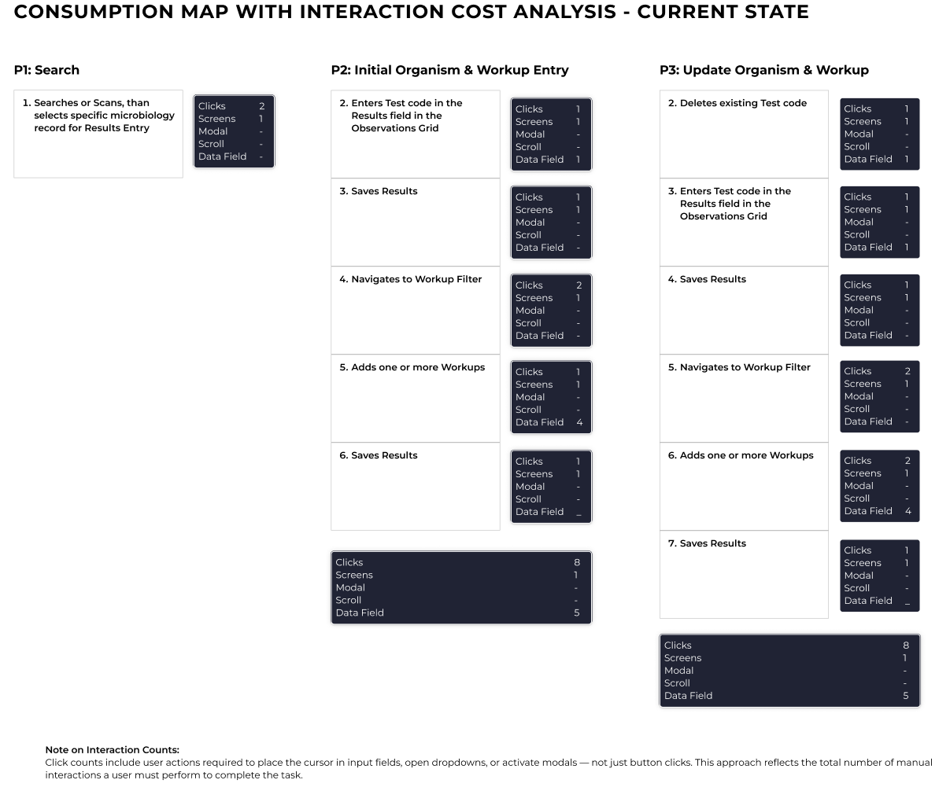
Figure 1. Consumption map with interaction cost analysis — current state.

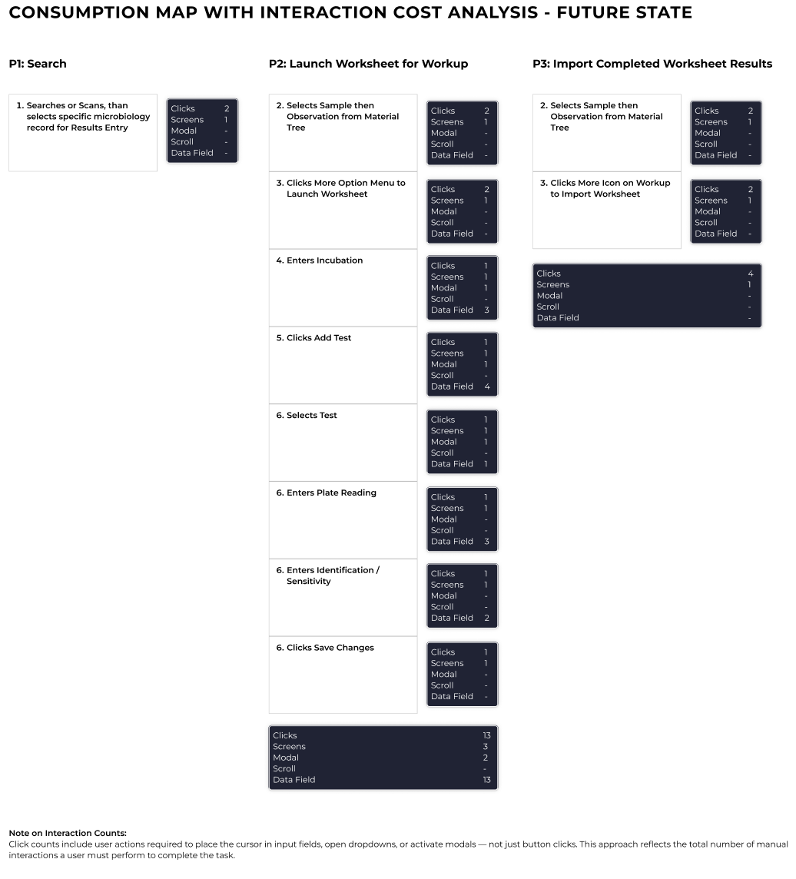
Figure 2. Consumption map with interaction cost analysis — future (proposed) state.

Summary
Metric | Current State | Proposed Workflow | Difference
Clicks | 18 | 19 | +1
Screens | 3 | 5 | +2
Modals | 0 | 2 | +2
Scroll Actions | 0 | 0 | 0
Data Entry Fields | 10 | 13 | +3

! IMPORTANT NOTE
Totals represent the cumulative interaction counts across all workflow phases shown in each diagram. Each phase reflects a distinct step in the microbiology workflow (e.g., initial organism entry followed by subsequent workup updates) and is included to represent the complete lifecycle of the representative workflow. Totals are intended to compare the overall interaction cost between the Current State and Proposed Workflow.

07 Key Findings
KF-01
● MEDIUM | Task-Based Architecture Increased Interaction Cost
OBSERVATION
The proposed workflow required additional interactions compared to the existing application.
EVIDENCE
Additional interactions resulted primarily from explicit task management, worksheet launching, structured workflow transitions, and increased data capture.
IMPACT
Click count increased only marginally overall (18 to 19). The added cost is concentrated in more screens (+2), the introduction of modal dialogs (0 to 2), and additional data entry fields (+3) — a change in workflow structure more than a broad increase in clicking. Framing the tradeoff around structure, rather than interaction count alone, more accurately reflects where the added effort sits.
RECOMMENDATION
Interaction cost should be evaluated alongside the workflow benefits introduced by the redesigned experience rather than viewed as an isolated metric.

KF-02
● LOW | Increased Visibility Improved Workflow Transparency
OBSERVATION
The proposed workflow significantly increased the visibility of specimen information, workflow status, and task progression.
EVIDENCE
Users gained immediate access to comments, task ownership, workflow state, relationships between laboratory materials, and contextual specimen information that previously required additional navigation or was not visible.
RECOMMENDATION
Continue emphasizing contextual information while ensuring important information remains easy to scan.

KF-03
Structured Tasks Improved Workflow Organization
● LOW
OBSERVATION
The proposed workflow organized laboratory activities into discrete, traceable tasks rather than consolidating multiple actions within a single workflow.
EVIDENCE
Task-based organization improved workflow transparency, ownership, and traceability throughout the specimen lifecycle.
RECOMMENDATION
Continue refining task organization while minimizing unnecessary transitions between related activities.

KF-04
● MEDIUM | Platform Constraints Influenced Workflow Design
OBSERVATION
Several workflow decisions were driven by platform architecture rather than usability preferences alone.
EVIDENCE
The solution was required to:
- Support both Clinical Microbiology and Environmental laboratories.
- Operate within a task-based Laboratory Management System.
- Maintain consistency with the broader Clinisys platform architecture.
RECOMMENDATION
Continue optimizing workflow efficiency within platform constraints while maintaining consistency across laboratory domains.

KF-05
● LOW | Additional Interactions Increased Workflow Value
OBSERVATION
Although interaction costs increased, many additional interactions directly supported improved workflow awareness and operational transparency.
EVIDENCE
Additional workflow steps exposed information that was previously hidden, including task ownership, specimen status, incubation progress, workup activities, and workflow relationships.
RECOMMENDATION
Evaluate future workflow improvements based on both interaction cost and the value each interaction provides to laboratory users.

KF-06
● MEDIUM | Modal Dialogs Are the Only Entirely New Interaction Type
OBSERVATION
Modal dialogs increased from zero in the Current State to two in the Proposed Workflow — the only metric that went from none to some, rather than changing incrementally.
EVIDENCE
Per Figure 2, both modal interactions occur in the Launch Worksheet path (P2): at "Clicks More Option Menu to Launch Worksheet" and "Clicks Add Test." No modal interactions appear anywhere in the Current State map (Figure 1).
IMPACT
Modal dialogs typically carry a higher interruption cost than an inline interaction with the same click count, since they block the underlying screen and require an explicit dismissal step. This makes the two new modals a more concentrated source of added friction than the +1 click difference alone would suggest.
RECOMMENDATION
Evaluate whether either modal in the Launch Worksheet path can be inlined into the surrounding screen or replaced with a non-modal control, since this is the most concrete, checkable opportunity to reduce interaction cost without removing the workflow value identified elsewhere in this analysis.

08 Workflow Value Assessment
The analysis demonstrated that increased interaction cost was accompanied by meaningful improvements in workflow value.
Increased Interaction Cost | Workflow Value Delivered
Additional clicks | Greater workflow visibility
More task transitions | Improved traceability
Structured workflows | Clear task ownership
Additional navigation | Better contextual awareness
Explicit workflow states | Improved transparency
Task-based organization | Scalability across Clinical and Environmental laboratories
Rows are paired by theme, not as one-to-one causal claims — no single cost item in the left column is asserted to directly cause the value item beside it.

09 Prioritized Recommendations
Priority | Recommendation | Timeline
High | Continue optimizing high-frequency workflow interactions | Future Design Iterations
High | Evaluate whether the two new modal dialogs in the Launch Worksheet path (KF-06) can be inlined or removed | Before Development
High | Preserve increased contextual visibility throughout the workflow | Ongoing
Medium | Reduce unnecessary task transitions where feasible | Future Enhancements
Medium | Continue improving onboarding for task-based workflows | Product Adoption
Low | Reassess interaction costs following implementation using production data | Post-Release

10 Research Impact

Benefits Identified
- Increased visibility of specimen information.
- Improved workflow traceability.
- Clearer task ownership.
- Greater consistency across laboratory workflows.
- Better alignment with the underlying platform architecture.
- Scalable workflow model supporting both Clinical and Environmental laboratories.

Tradeoffs
- Increased interaction cost.
- Additional navigation.
- Greater initial learning curve.
- More explicit workflow transitions.

Overall Assessment
The additional interactions primarily support improved transparency, traceability, and workflow consistency rather than unnecessary complexity.

11 Conclusion
The Consumption Map and Interaction Cost Analysis confirmed that the proposed workflow introduces a measurable increase in interaction cost compared to the existing application. However, the additional interactions are largely the result of intentional design decisions that improve workflow transparency, traceability, and task organization rather than unnecessary complexity.
The proposed solution was developed within the constraints of a shared, task-based Laboratory Management System that supports both Clinical Microbiology and Environmental laboratory workflows. These architectural requirements influenced several workflow patterns and distinguish the solution from traditional patient-centric Laboratory Information Systems.
While users perform more interactions to complete certain tasks, they also gain significantly greater visibility into specimen status, task ownership, workflow progression, and contextual information throughout the testing process.
Overall, the analysis indicates that the increased interaction cost represents a strategic tradeoff that enables a more transparent, scalable, and maintainable workflow. Future optimization efforts should focus on reducing unnecessary interactions while preserving the workflow value delivered by the redesigned experience.

