UX Research Findings & Design Recommendations
Clinical Microbiology Setup & Resulting
Interactive Prototype Evaluation (Round 2)

PRODUCT | Clinisys Laboratory Solution (CLS)
PREPARED BY | Rossana Babakhani, UX Researcher
RESEARCH METHOD | Moderated Usability Testing

CONTENTS
Table of Contents
Overview 1
Study Snapshot 1
Research Progress 1
Study Details 1
Research Method 1
Participants 1
Research Objectives 1
Tasks Evaluated 1
Design Changes Validated 1
Key Findings 1
Validated Design Decisions 1
Prioritized Recommendations 1
Research Impact 1
Design Improvements Influenced by Research 1
Outstanding Considerations 1
Research Outcome 1

01 Overview
This second round of usability testing evaluated the interactive prototype for the Clinical Microbiology Setup & Resulting workflow. The prototype incorporated design refinements based on findings from the initial wireframe evaluation and focused on validating end-to-end workflows, navigation, task efficiency, and overall usability prior to development.
Participants completed representative Clinical Microbiology workflows while providing feedback on workflow alignment, navigation, task efficiency, and overall usability. The sessions also evaluated whether design changes introduced after the wireframe evaluation successfully addressed previously identified concerns and supported real-world laboratory workflows.

02 Study Snapshot
Detail | Description
Project | Clinical Microbiology Setup & Resulting
Evaluation | Interactive Prototype (Round 2)
Research Method | Moderated Usability Testing
Participants | 5 Clinical Microbiology client representatives
Session Length | Five 60-minute individual sessions
Format | Remote, one-on-one
Prototype | Interactive high-fidelity prototype
Primary Focus | Workflow validation, navigation, task efficiency, and usability

03 Research Progress
This study built upon the findings from the initial wireframe evaluation by validating design refinements incorporated into the interactive prototype.
Metric | Round 1 | Round 2
Prototype Evaluated | Low-fidelity wireframes | Interactive high-fidelity prototype
Participants | 5 | 5
Session Length | Five 60-minute sessions | Five 60-minute sessions
Primary Goal | Validate workflow concepts and information architecture | Workflow validation, navigation, task efficiency, and usability
Outcome | Identified terminology, workflow, and information architecture improvements | Validated workflow direction; identified opportunities to improve workflow efficiency, onboarding, and terminology adoption

04 Study Details
The evaluation consisted of moderated usability testing sessions conducted using an interactive prototype. Participants completed representative Clinical Microbiology workflows while thinking aloud and providing feedback on workflow alignment, navigation, efficiency, and usability. A moderator guided each session, observed participant interactions, and documented usability observations and participant feedback.

Research Method
- Method: Moderated usability testing
- Prototype: Interactive high-fidelity prototype
- Session Length: 60 minutes
- Participants: 5 client representatives
- Format: Remote, one-on-one sessions
- Approach: Scenario-based task completion using representative Clinical Microbiology workflows

05 Participants
Five Clinical Microbiology professionals representing client laboratories participated in the study. Participants had extensive experience performing routine microbiology workflows and evaluated the prototype using realistic laboratory scenarios. Their feedback reflected current laboratory practices, workflow expectations, and operational requirements.

06 Research Objectives
- Validate workflow refinements introduced after the wireframe evaluation.
- Evaluate the usability of the interactive prototype.
- Assess workflow efficiency across common microbiology tasks.
- Validate navigation between specimen-related information.
- Identify remaining usability concerns prior to development.
- Confirm whether previous research findings had been successfully addressed.

07 Tasks Evaluated
Participants completed representative Clinical Microbiology workflows including:
- Locating work from the backlog.
- Creating personalized worklists from the backlog.
- Completing specimen setup.
- Reviewing automatically configured plates.
- Adding or removing plates when appropriate.
- Navigating between specimen pages.
- Reviewing specimen summary information.
- Reviewing specimen documents.
- Entering Gram stain results.
- Adding observations to plates.
- Completing resulting activities.

08 Design Changes Validated
The interactive prototype incorporated several improvements based on findings from the wireframe evaluation.
Design Change | Validation Outcome
Increased visibility of specimen comments | Participants found important information easier to locate.
Interactive end-to-end workflow | Successfully validated through representative laboratory scenarios.
Personalized worklists | Highly valued for organizing daily work.
Material navigation refinements | Became intuitive after brief use and was viewed positively.
Workflow refinements | Supported successful task completion; participants continued to perceive an increase in workflow interactions.

9 Key Findings
KF-01
Shared Terminology Increased the Learning Curve | ● MEDIUM

OBSERVATION
Participants continued to experience confusion with terminology throughout the application. This finding was consistent with the wireframe evaluation.
EVIDENCE
Participants questioned terminology that differed from their current Clinical Microbiology systems and occasionally required clarification during testing.
IMPACT
Continued terminology confusion may extend onboarding time for new users, though it occurred only occasionally this round and did not prevent task completion.
RECOMMENDATION
The terminology supports both Clinical and Environmental laboratory workflows within a shared platform and therefore could not be modified for this feature. Support adoption through user training, onboarding, and product documentation.
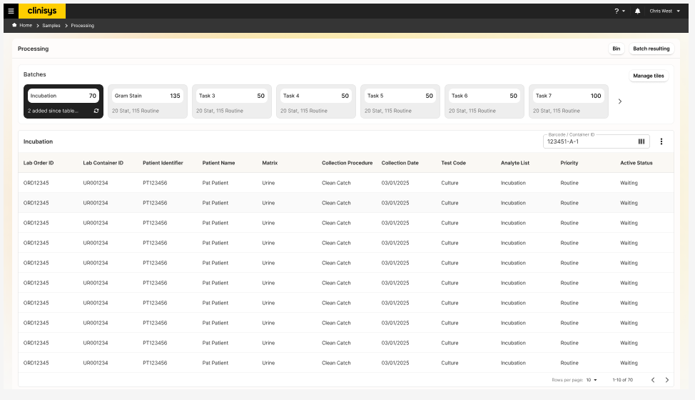

KF-02
Material-Based Navigation Was Well Understood After Initial Use | ● LOW

OBSERVATION
Participants initially required time to understand the material-based navigation model. After completing representative workflows, most participants viewed the organization positively.
EVIDENCE
Users reported that once they understood the relationships between materials, navigation became intuitive and provided a clear representation of the specimen lifecycle.
IMPACT
The initial learning curve may create brief friction for new users, but does not appear to affect usability once the navigation model is understood.
RECOMMENDATION
Continue refining onboarding materials and visual cues that reinforce material relationships during initial system adoption.
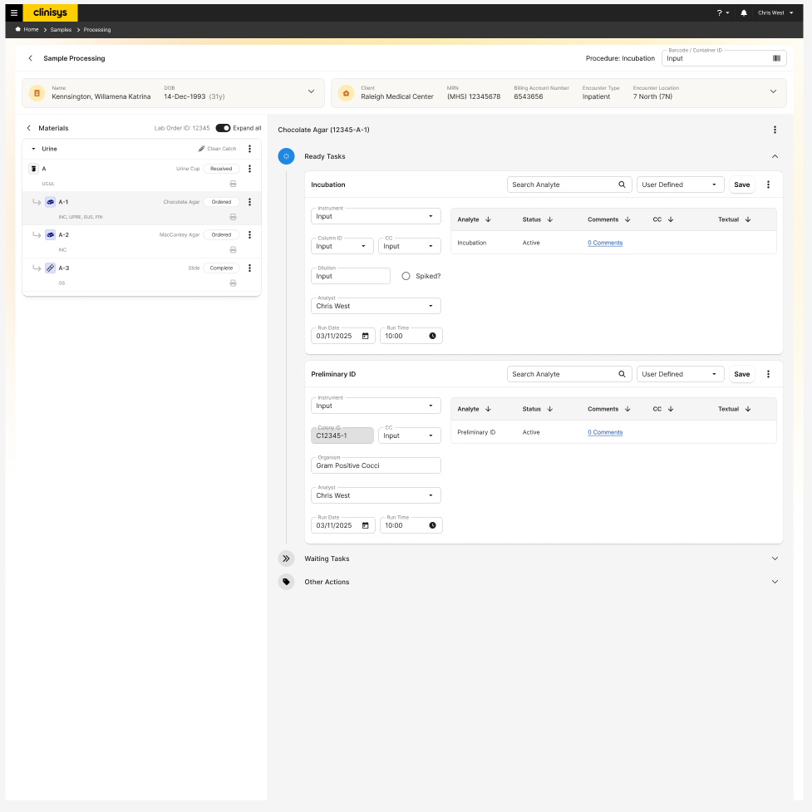

KF-03
Workflow Efficiency Requires Objective Measurement | ● HIGH

OBSERVATION
Participants consistently perceived that the prototype required substantially more clicks than their current laboratory systems.
EVIDENCE
Although participants successfully completed representative workflows, they described the task-based workflow as requiring additional navigation and interaction. The feedback reflected perceived workflow effort rather than measured inefficiency.
IMPACT
If perceived inefficiency reflects a genuine increase in interaction effort, it could affect adoption and daily productivity; since this round captured perception rather than measured data, the actual effect on efficiency is unconfirmed and should be validated objectively before development proceeds.
RECOMMENDATION
Conduct a Consumption Report (Cost of Interaction analysis) comparing the current workflow with the proposed design. Measure objective interaction metrics—including clicks, navigation steps, screens visited, and task completion effort—to determine whether the proposed workflow introduces additional effort or simply redistributes interactions. Use these findings to guide future workflow optimization.

KF-04
Increased Context Improved Workflow Awareness | ● LOW

OBSERVATION
Participants appreciated the increased visibility of specimen comments and contextual information throughout the workflow.
EVIDENCE
Users reported that having comments readily available reduced the need to navigate to other areas of the application to retrieve important specimen information.
IMPACT
Surfacing this information directly in the workflow reduces navigation overhead and appears to meaningfully improve efficiency during resulting tasks.
RECOMMENDATION
Continue surfacing high-value specimen context throughout the workflow while maintaining a clean and uncluttered interface.
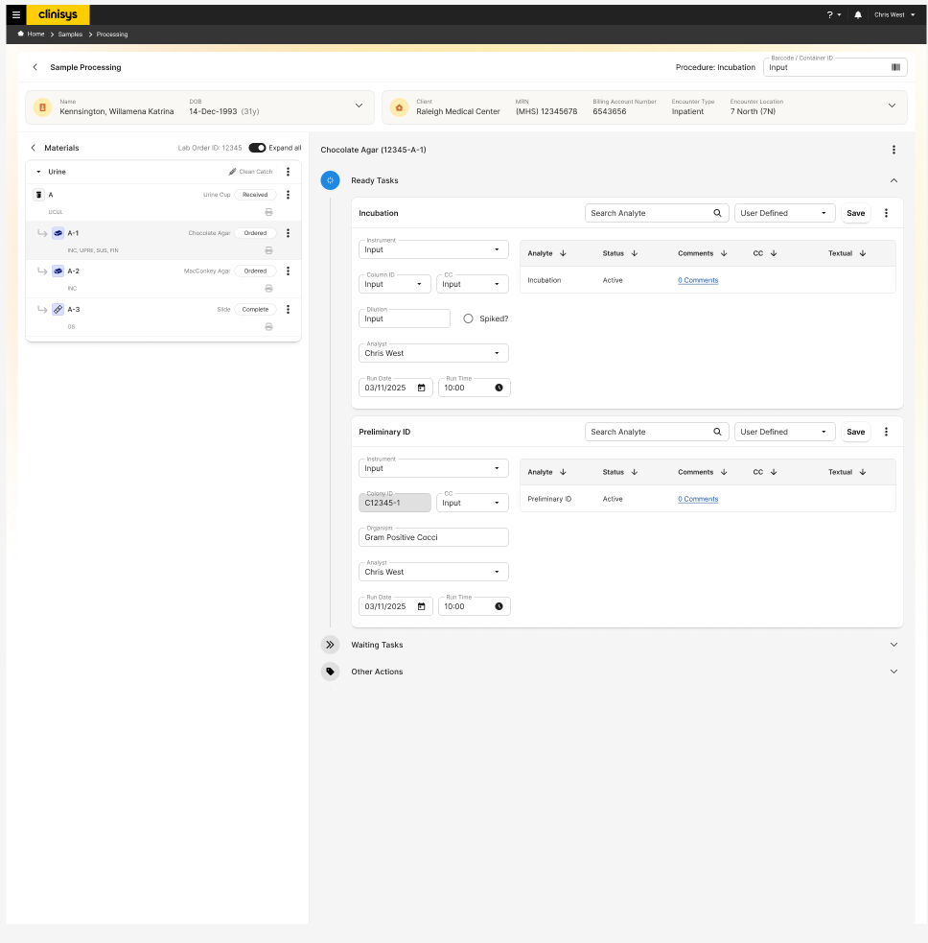

10 Validated Design Decisions
The study confirmed several design decisions that effectively supported Clinical Microbiology workflows.
Task-Based Workflow
Confirmed the task-based workflow supports representative Clinical Microbiology activities.
Personalized Worklists
Participants consistently valued the ability to organize and prioritize work directly from the backlog.

Material-Based Navigation
Although unfamiliar initially, participants reported that the organization became intuitive after working through representative scenarios.
Increased Contextual Information
Improved visibility of comments and specimen details reduced the need to navigate elsewhere for critical information.
Automatic Plate Configuration
Participants continued to support backend-driven plate generation while allowing additional plates to be added or removed, when appropriate.

11 Prioritized Recommendations
Priority | Recommendation | Timeline
High | Conduct a Consumption Report comparing the current and proposed workflows | Before Development
High | Continue enhancing personalized worklists | Future Design Iterations
Medium | Improve onboarding for the material-based navigation model | Product Adoption
Medium | Continue increasing visibility of contextual specimen information | Future Design Iterations
Low | Support shared terminology through training and documentation | Implementation

12 Research Impact
The second round of usability testing provided confidence that the proposed workflow aligned with the needs of Clinical Microbiology users while identifying targeted opportunities for refinement prior to development, and confirmed the validated design decisions summarized in Section 10.

Design Improvements Influenced by Research
- Validated the introduction of personalized worklists.
- Reinforced the value of increased visibility of specimen comments and contextual information.
- Identified workflow efficiency as the next area requiring objective analysis.
- Confirmed the need for onboarding to support adoption of the material-based navigation model.
- Reinforced the decision to maintain shared terminology across the Clinical and Environmental platforms.

Outstanding Considerations
- Conduct a Consumption Report (Cost of Interaction analysis) to objectively compare workflow efficiency.
- Continue evaluating opportunities to optimize navigation without compromising workflow flexibility.
- Support adoption of shared terminology through documentation and onboarding.
- Continue refining onboarding materials to reduce the initial learning curve.

13 Research Outcome
The interactive prototype successfully validated the overall workflow direction established during the initial wireframe evaluation. Participants completed representative workflows successfully and responded positively to key design improvements, including personalized worklists, increased visibility of contextual information, and the refined material-based navigation model.
The remaining feedback focused primarily on adoption and workflow optimization rather than fundamental usability concerns. Overall, the findings indicate that the proposed solution is well-positioned to progress into development while continuing to refine workflow efficiency through objective interaction analysis.

