UX Research Findings & Design Recommendations
Clinical Microbiology Setup & Resulting
Wireframe Evaluation (Round 1)

PRODUCT | Clinisys Laboratory Solution (CLS)
PREPARED BY | Rossana Babakhani, UX Researcher
RESEARCH METHOD | Moderated Usability Testing

CONTENTS
Table of Contents
Overview 1
Study Snapshot 1
Study Details 1
Research Method 1
Participants 1
Research Objectives 1
Tasks Evaluated 1
Key Findings 1
Validated Design Decisions 1
Prioritized Recommendations 1
Research Impact 1
Design Improvements Influenced by Research 1
Outstanding Considerations 1
Research Outcome 1

01 Overview
This first round of usability testing evaluated the low-fidelity wireframes for the Clinical Microbiology Setup & Resulting workflow. The study focused on validating proposed workflows, information architecture, terminology, and navigation before investing in high-fidelity prototype development.
Participants completed representative microbiology scenarios while providing feedback on workflow alignment, usability, and laboratory-specific processes. The sessions identified opportunities to improve terminology, workflow completeness, information architecture, and visibility of critical specimen information. The findings established the design priorities that guided development of the interactive prototype evaluated during the second round of usability testing.

02 Study Snapshot
Detail | Description
Project | Clinical Microbiology Setup & Resulting
Evaluation | Wireframe Evaluation (Round 1)
Research Method | Moderated Usability Testing
Participants | 5 Clinical Microbiology client representatives
Session Length | Five 60-minute individual sessions
Format | Remote, one-on-one
Prototype | Low-fidelity wireframes
Primary Focus | Workflow concepts, information architecture, terminology, and usability

03 Study Details
The evaluation consisted of moderated usability testing sessions using low-fidelity wireframes. Participants completed representative Clinical Microbiology workflows while thinking aloud and discussing how the proposed concepts aligned with their existing laboratory processes.
The sessions focused on validating workflow concepts rather than interface interactions, allowing participants to provide feedback on information architecture, terminology, navigation, and workflow completeness before higher-fidelity designs were created.

Research Method
- Method: Moderated usability testing
- Prototype: Low-fidelity wireframes
- Session Length: 60 minutes
- Participants: 5 client representatives
- Format: One-on-one remote sessions
- Approach: Scenario-based workflow walkthroughs

04 Participants
Five Clinical Microbiology professionals representing client laboratories participated in the evaluation. Participants had extensive experience performing routine microbiology workflows and provided feedback based on current laboratory practices, workflow expectations, and operational requirements.

05 Research Objectives
- Validate the proposed Clinical Microbiology workflow.
- Evaluate worklist navigation for single-piece and batch workflows.
- Assess specimen setup and plate configuration workflows.
- Evaluate observation and sub-plate workflows.
- Validate the proposed information architecture.
- Identify terminology, workflow, and usability issues before prototype development.

06 Tasks Evaluated
Participants completed representative workflow scenarios including:
- Navigating the microbiology worklist.
- Locating work using barcode scanning.
- Configuring specimen setup.
- Reviewing automatically configured plates.
- Adding or removing plates.
- Creating observations.
- Creating sub-plates.
- Navigating the material hierarchy.
- Reviewing batch-resulting concepts.

07 Key Findings
KF-01
Shared Terminology Did Not Match Clinical Laboratory Expectations | ● HIGH
OBSERVATION
Participants experienced confusion with several system terms that differed from terminology commonly used in Clinical Microbiology laboratories.
EVIDENCE
Participants questioned terminology including:
- Backlog
- Aliquot
- Matrix
Participants suggested terminology such as:
- Pending List
- Order ID
- Plates
IMPACT
Unfamiliar terminology increases cognitive effort and slows task completion, and is likely to require additional onboarding or documentation for users to reach proficiency with the platform.
RECOMMENDATION
Evaluate opportunities to adopt Clinical Microbiology terminology where feasible or provide configurable terminology. If shared platform terminology is required, support adoption through onboarding and documentation.
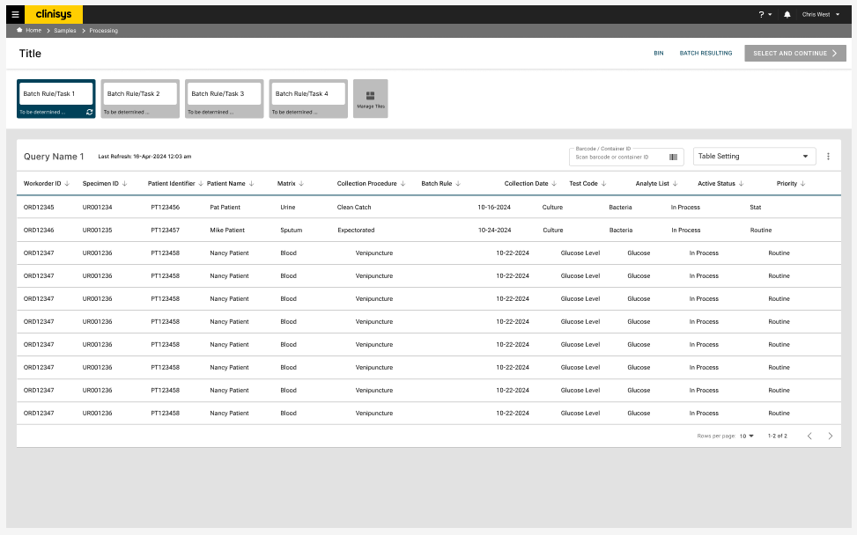

KF-02
Laboratory Roles Perform Distinct Workflow Responsibilities | ● HIGH

OBSERVATION
Participants described receiving, specimen setup, incubation, and resulting as distinct workflow responsibilities performed by different laboratory roles.
EVIDENCE
Receiving and setup were consistently described as separate activities with minimal overlap.
IMPACT
Designing around a single end-to-end user risks a workflow that does not match how laboratories actually divide these responsibilities, which could reduce efficiency for role-specific users.
RECOMMENDATION
Design workflows that support role-specific responsibilities rather than assuming a single user performs the complete end-to-end workflow.
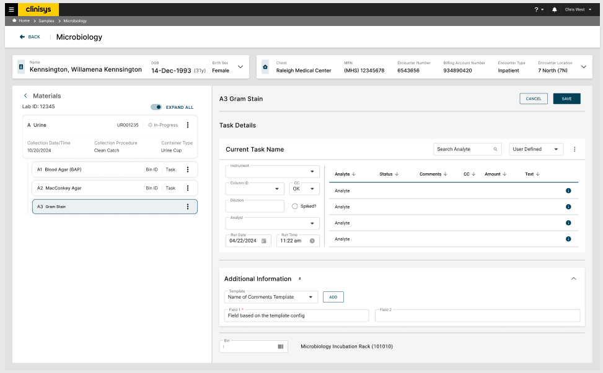

KF-03
Critical Laboratory Workflows Were Missing | ● HIGH

OBSERVATION
Participants identified several workflows that were not represented within the proposed design.
EVIDENCE
Missing workflows included:
- Setup time tracking
- No-growth resulting
- Mixed flora workflows
IMPACT
Without these workflows, the design does not yet reflect the full range of scenarios laboratories encounter in routine production use, which could require rework later in development if not addressed now.
RECOMMENDATION
Incorporate these workflows into future design iterations before development.

KF-04
Plate Management Should Primarily Be System Driven | ● MEDIUM

OBSERVATION
Participants preferred automatic plate generation based on backend configuration rather than manually adding plates.
EVIDENCE
Users indicated that manual plate management should only occur in exceptional circumstances and should be controlled through permissions.
IMPACT
Unnecessary manual plate management increases workload and introduces opportunities for error; keeping it exceptional and permission-controlled reduces that risk.
RECOMMENDATION
Maintain automatic plate configuration while supporting optional user modifications through configurable permissions.

KF-05
Personalized Worklists Added Meaningful Workflow Flexibility
● LOW
OBSERVATION
Participants responded positively to the ability to create personalized worklists directly from the backlog.
EVIDENCE
Users appreciated being able to organize pending work according to their own priorities instead of relying solely on predefined worklists.
IMPACT
Personalized worklists appear to improve participants' sense of control over their daily work, supporting continued investment in this capability.
RECOMMENDATION
Continue expanding personalized worklist capabilities, including filtering, sorting, and management features.
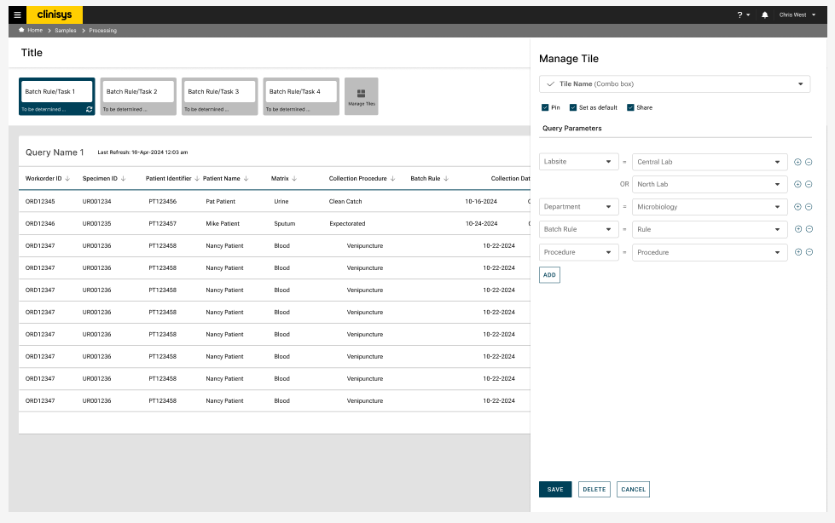

KF-06
Greater Context Was Needed During Resulting | ● MEDIUM

OBSERVATION
Participants requested additional specimen information while performing microbiology work.
EVIDENCE
Requested information included:
- Order comments
- Special requests
- Specimen modifiers
- Wound location
- Other pending microbiology work
IMPACT
Without this information visible in the primary workspace, users must leave their workflow to retrieve it elsewhere, adding friction to time-sensitive resulting tasks.
RECOMMENDATION
Increase the visibility of contextual specimen information throughout the workflow.

KF-06
Material-Based Navigation Required User Orientation | ● MEDIUM

OBSERVATION
Participants initially found the material hierarchy unfamiliar because it differed from their existing laboratory systems.
EVIDENCE
After explanation, participants understood the relationships between materials and recognized the potential value of the proposed organization.
IMPACT
Users transitioning from existing laboratory systems may need onboarding to adopt this navigation model, though the underlying structure was not rejected outright once explained.
RECOMMENDATION
Continue refining the material hierarchy while improving terminology and visual cues to reduce the learning curve.

08 Validated Design Decisions
Although participants identified several opportunities for improvement, the study also validated important aspects of the proposed design.
Overall Workflow Direction
Confirmed the overall direction of the proposed Clinical Microbiology workflow.
Automatic Plate Configuration
Participants supported backend-driven plate configuration.
Barcode Workflow
Barcode-driven workflow initiation aligned well with laboratory processes.
Batch Resulting Concept
Participants viewed batch-resulting as a valuable capability for improving workflow efficiency.
Material Relationships
Once understood, the proposed material hierarchy effectively communicated relationships between specimens, plates, observations, and sub-plates.

09 Prioritized Recommendations
Priority | Recommendation | Timeline
High | Implement missing microbiology workflows | Next Design Iteration
High | Increase visibility of contextual specimen information | Next Design Iteration
High | Support role-based workflow responsibilities | Next Design Iteration
Medium | Refine terminology where possible | Product Design
Medium | Improve presentation of the material hierarchy | Prototype Iteration
Low | Introduce configurable permissions for plate management | Future Release

10 Research Impact
The wireframe evaluation established the design direction for the Clinical Microbiology Setup & Resulting workflow and identified the highest-priority opportunities for refinement before prototype development, while confirming the validated design decisions summarized in Section 08.

Design Improvements Influenced by Research
The findings directly informed the development of the interactive prototype by:
- Increasing the visibility of specimen comments and contextual information.
- Introducing personalized worklists from the backlog.
- Refining the material-based navigation model.
- Expanding workflow coverage to include previously missing laboratory scenarios.
- Improving end-to-end workflow continuity.

Outstanding Considerations
- Evaluate terminology constraints within the shared Clinical and Environmental platform.
- Continue refining the material-based navigation model.
- Validate workflow efficiency through interactive prototype testing.

11 Research Outcome
The wireframe evaluation validated the overall direction of the proposed Clinical Microbiology workflow while surfacing several substantive gaps — most notably missing workflows, mismatched terminology, and insufficient contextual information — that needed to be addressed before development, alongside more incremental refinements to navigation and structure. These findings guided development of the interactive prototype.
The resulting design improvements became the focus of the second round of usability testing, where they were further validated and refined before implementation.

